“Tear-Water Tea”

from Owl at Home

by Arnold Lobel

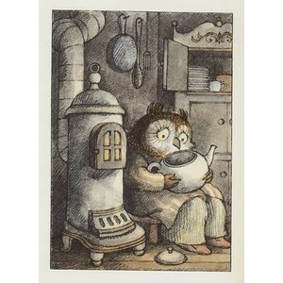

Owl took the kettle out of the cupboard. “Tonight I will make tear-water tea,” he said. He put the kettle on his lap.

“Now, said Owl, “I will begin.” Owl sat very still. He began to think of things that were sad. “Chairs with broken legs,” said Owl. His eyes began to water. “Songs that cannot be sung,” said Owl, “because the words have been forgotten.”

1.

What kind of chairs made Owl sad?

Chairs that were hard

Chairs that were brown

Chairs with broken legs

2.

What does Owl need to do so that he can make tear-water tea?

To cry

To sleep

To clean

3.

Another name for sad is…

happy

friendly

miserable